Project Report: Linux Hardening Audit Tool
Author: Mazin Abdul Azeez
Internship: Cyber Security Internship
Company: Elevate Labs

1. Introduction
System hardening is a foundational element of cyber security. It involves securing a system's configuration and reducing its attack surface to protect it from threats. This project, undertaken as part of the Elevate Labs Cyber Security Internship , focuses on the development of an automated "Linux Hardening Audit Tool".
The primary objective of this tool is to automatically audit a live Linux system's security configuration against a predefined set of security benchmarks. In an environment where manual checks are time-consuming and prone to error, this script provides a fast, repeatable, and scalable method to identify common misconfigurations and potential vulnerabilities.

2. Abstract
This report details a lightweight, script-based auditing tool designed to analyze the security posture of a Linux system. The tool is written entirely in Python 3 and leverages the built-in subprocess module to execute and interpret the output of native Linux shell commands.
The script performs a series of critical checks, including:
- Verifying restrictive file permissions on sensitive files like /etc/shadow.
- Auditing the SSH (Secure Shell) configuration for insecure settings, such as PermitRootLogin.
- Confirming that a host-based firewall (like UFW) is active and enabled.
- Scanning for insecure legacy services (like telnet) that may be running.
The tool generates a real-time report directly to the console, clearly marking each check with a PASS or FAIL status. For failed checks, it provides a simple, actionable recommendation for remediation. The audit concludes with a final compliance score, offering an at-a-glance summary of the system's overall security health.

3. Tools Used
The project was developed and tested using the following tools and technologies:
- Python 3: The core programming language used to build the logic of the audit script.
- Python subprocess Module: The key library used to run shell commands from within Python, capture their output (stdout), and check for errors (stderr).
- Bash Shell: The script executes various Bash commands (e.g., ls, grep, systemctl, ufw status) to interact with and query the operating system's configuration¹¹.
- Kali Linux: The Linux distribution used as the development and testing environment for the audit tool.

4. Steps Involved in Building the Project
The development of the tool followed a logical, step-by-step process:
- Environment and Imports: The project was set up as a single Python file (audit_tool.py). The subprocess module was imported to provide the core functionality.
- Core Helper Function: A helper function named run_command was created. This function takes a shell command as a string, executes it using subprocess.run(), and returns the captured stdout and stderr. This reusable function simplified the rest of the script.
- Audit Check Implementation: Several audit checks were implemented:
  - Check 1 (File Permissions): A check was written to validate the permissions of /etc/shadow¹². It runs ls -l /etc/shadow and checks if the permission string matches a secure state (e.g., -r--------).
  - Check 2 (SSH Hardening): A check was added to grep the /etc/ssh/sshd_config file for the PermitRootLogin directive. The check fails if the value is not explicitly set to no.
  - Check 3 (Firewall Status): The script runs sudo ufw status and parses the output to ensure the firewall "Status" is "active". This check requires the user to run the script with sudo privileges.
  - Check 4 (Insecure Services): A check was implemented using systemctl is-active telnet.socket to determine if the insecure telnet service is running.
- Scoring and Reporting: Two variables, score and total_checks, were created. For each PASS, the score is incremented. At the end of the script, a final compliance score is printed, giving the user a quantitative measure of their system's security.

5. Code
Below is the code of the report generator tool:
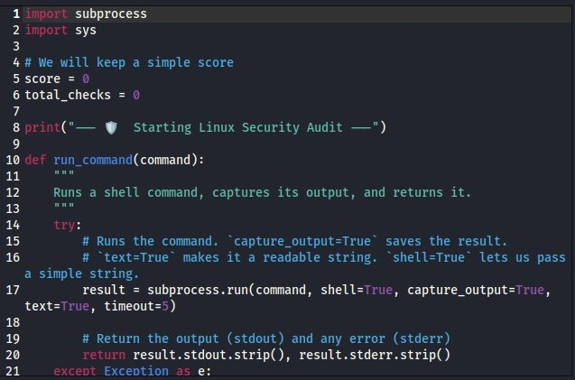

6. Sample Output / Report
Below is a sample of the report generated by the tool when run on the test system: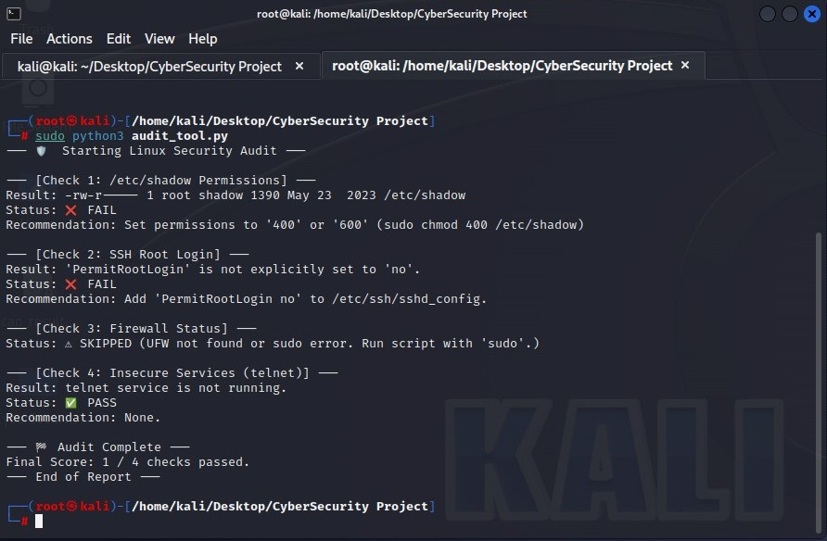

6. Conclusion
This project was a success. The "Linux Hardening Audit Tool" was built and functions as intended, fulfilling all project objectives. The tool is capable of performing a series of essential security checks on a Linux system and generating a clear, easy-to-understand report with remediation steps.
The final script is efficient, lightweight, and requires no external dependencies beyond a standard Python 3 installation. During testing on the Kali Linux environment, the system passed 1 out of 4 checks, demonstrating an insecure configured.
This tool serves as an excellent foundation for a more robust auditing utility. Future work could involve adding dozens of new checks based on CIS (Center for Internet Security) benchmarks, adding a graphical user interface (GUI), or integrating a feature to automatically fix the misconfigurations it finds.

